Classic South Africa

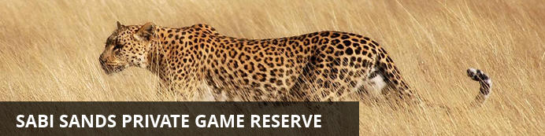
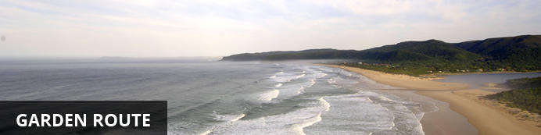
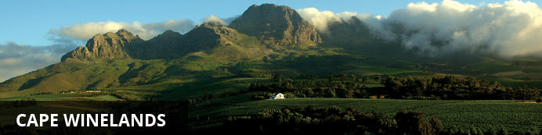
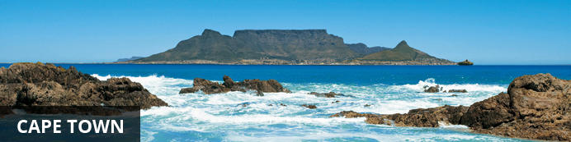

Classic South Africa
Kruger National Park - Plettenberg Bay - Hermanus - Franschhoek - Cape Town
15 Days / 14 Nights
Costs from £2,995.0 per person based on 2 sharing
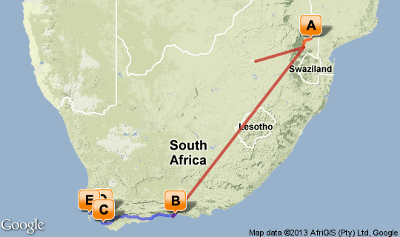

Click here to view your Virtual Itinerary

Overview
The Classic self-drive tour - combining the wildlife of Mpumalanga, the famed Garden Route and the varied attractions of the Cape.

Destination | Accommodation | Nights | Basis | Room Type
Kruger National Park | Sabi Sabi Bush Lodge | 3 | FB+
Plettenberg Bay | Hog Hollow Country Lodge | 2 | B&B
Hermanus | The Marine | 2 | B&B
Franschhoek | The Last Word Franschhoek | 2 | B&B
Cape Town | Kensington Place | 3 | B&B

Key
B&B: Bed and breakfast. D, B&B: Dinner, bed and breakfast. FB: Dinner, bed, breakfast and lunch. FB+: Dinner, bed, breakfast, lunch and activities daily. FI: Fully inclusive.

Day 1: Travelling

Travelling

Days 2-5: Sabi Sabi Bush Lodge, Sabi Sands Private Game Reserve

Sabi Sands Private Game Reserve
The Sabi Sands is South Africa's premier private game viewing destination. It was here that the southern African safari began and today this famous reserve offers exceptional game viewing and equally exceptional accommodations. It covers 65,000 hectares and shares a common 50km unfenced boundary with the Kruger National Park to the east. Two perennial rivers, the Sabi and the Sand flow through this Game Park, sustaining the diverse fauna and flora of the area, which enjoys one of the highest and most bio-diverse wildlife populations of any area in Africa.
Due to considerate game viewing practises, the trackers and game rangers of the various Lodges are able to offer exceptional game viewing of all the general game species, as well as the high profile animals. The success of viewing leopard within this area is legendary. Elephants, lion, rhino, buffalo, cheetah, giraffe, zebra and a vast variety of antelope and other species can be closely observed within their own ranges. This greater area is home to 336 tree, 49 fish, 34 amphibian, 114 reptile, 507 bird and 147 mammal species.

Overnight: Sabi Sabi Bush Lodge View iBrochure
Bush Lodge is celebrated the world over for its warmth, vibrancy, 5-Star luxury and exceptional safaris. Huge wooden viewing decks overlook a busy waterhole; and each suite features sumptuous linens and fabrics, beautiful leather and wood furnishings, and an en-suite glass fronted bathroom with indoor and al-fresco shower leading onto a private patio. The lounge, bar, pool area and boma are all relaxing meeting places where stories are shared and friends made.
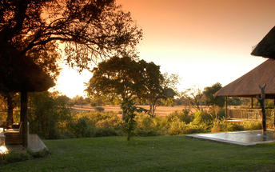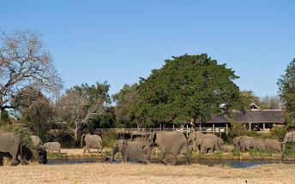

Included
Dinner, Bed, Breakfast, Lunch and Activities
Drinks (Local Brands)

Days 5-7: Hog Hollow Country Lodge, Garden Route

Garden Route
With its great beaches along a narrow strip of fertile land nestled between majestic mountains and the big blue Indian Ocean the Garden Route is one of South Africa’s premier holiday destinations.

Overnight: Hog Hollow Country Lodge
"If you can spend a perfectly useless afternoon in a perfectly useless manner, you have learned how to live" Lin Yutang (1895 – 1976)
Set on the edge of indigenous forest, with breathtaking views of the valleys and Tsitsikamma Mountains. Enjoy outstanding cuisine, stylish accommodation, panoramic views and friendly hospitality. Sixteen unique African-styled suites situated in the lush gardens around the main house, offer private wooden decks, hammocks, king sized beds & most have cosy fireplaces.
Mouth watering breakfasts are served out on the boma deck, while scrumptious communal dinners are served in the conviviality of the candle-lit main house.
Activities range from lazing at the long, blue pool, taking a sauna, a forest walk to a primate sanctuary, over 50 charted walks, horse riding, golf, world’s highest bungy jump, boat-based whale & dolphin watching, treetops canopy walk or a scenic glider flight around the bay. The list is endless ...
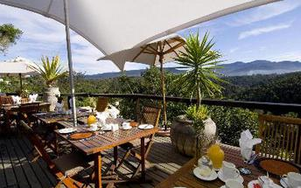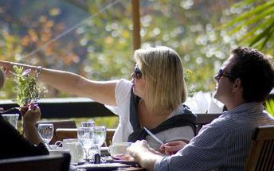

Included
Bed and Breakfast

Day 7-9: The Marine, Whale Coast

Whale Coast
This rugged stretch of South African coastline snakes along the Atlantic Ocean, with magnificent mountains rising up on the other side. The spectacular scenery is made up of charming seaside villages, farms, rivers, coves and valleys, and during the right season, the region’s namesake – whales – can be seen cruising and wallowing in the coastal waters.

Overnight: The Marine View iBrochure
The Marine is one of the southern hemisphere’s most spectacular seaside Relais & Châteaux properties. Perched on the cliffs, overlooking Hermanus's Walker Bay, The Marine boasts 42 individually decorated bedrooms and suites. This unforgettable property overlooks South Africa’s most pristine whale sanctuary, and it is just a stone’s throw from one of the greatest densities of the endangered Great White Shark, and selection of fynbos species in the Cape. The Marine offers guests the unique opportunity to experience the finest land-based whale watching in the world. From June to September guests are able to view these majestic creatures from the comfort of their beautiful sea-facing bedroom. The attention to detail is apparent in every aspect of this remarkable owner managed property – from the personal service to the exceptional cuisine, the perfect-for-sundowners Sun Lounge and the in-house Carchele Beauty Spa. Each piece of The Marine story adds another element to an unforgettable stay.
Services & Facilities: Air-conditioned rooms and 2 restaurants, car park, room service, security. Spa, Conference room, Boutique and Traveldesk, Tidal Pool, Internet Lounge.
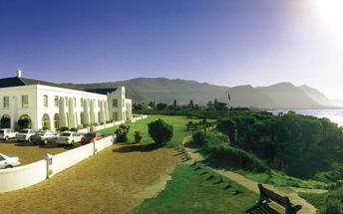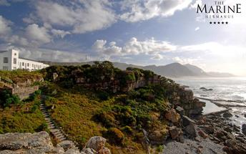

Included
Bed and Breakfast

Days 9-11: The Last Word Franschhoek, Cape Winelands

Cape Winelands
A mere one hour drive from Cape Town lie the valleys and mountains which have become synonymous with some of the world finest wines. Spectacular mountain scenery, fine hotels and guest houses, 300 years of wine making history and many of the country’s top restaurants combine to make the Cape Winelands into a much desired destination. This is the centre of South Africa’s award winning wine industry and places of interest include Stellenbosch, Franschhoek and numerous award winning wine estates.

Overnight: The Last Word Franschhoek
The Last Word Franschhoek is an exclusive five star historic residence in the heart of Franschhoek’s village, the gourmet capital of South Africa. It’s only a minute’s walk from the many excellent award-winning restaurants and numerous character-filled boutique style shops and art galleries.
The magnificent Franschhoek valley offers world-class wine estates, tastings and cellar tours nestled between towering mountains and beautiful vineyards and the picturesque traditional French village hosts some of the best cuisine from internationally recognised gourmet chefs. Of South Africa’s top ten restaurants, three are in Franschhoek and there is a choice of more than 30 different places to wine and dine.
Beautifully restored in the Cape Huguenot tradition, Beautifully restored in the Cape Huguenot tradition, The Last Word Franschhoek has been designed with sumptuous home comforts creating an elegant, sophisticated interior with a handsome mixture of classic and contemporary furnishings.
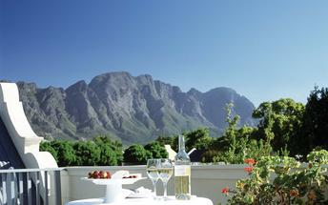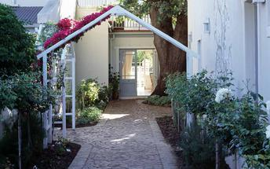

Included
Bed and Breakfast

Days 11-14: Kensington Place, Cape Town

Cape Town
Cape Town is one of the world's most beautiful cities and a top international destination. Large volumes of tourist flock to Cape Town to enjoy this unique city with it's fascinating history, interesting culture, natural beauty, award winning wines and laidback lifestyle. Whether you are a serious tourist or just want to lie on the beach and enjoy life Cape Town will satisfy your needs.

Overnight: Kensington Place View iBrochure
Where Cape Town gets hip and comfortable! This contemporary private hotel combines cutting-edge design with a tranquil but prime location off trendy Kloof Street, below Table Mountain. Eight bespoke en-suite guest rooms with extra length king size beds (superior rooms) and private outdoor terraces. A team of friendly staffers who are almost telepathic, its not such a stretch to feel you are staying in a private home. Yet this is a private home styled by someone with immaculate taste, the finest linens used on the beds, the thickest towels used in the bathrooms and flat-screen TVs, iPod docking stations and personal laptops with complementary Wi-fi access are just a few of the modern accessories.
Breakfasts served till 15h00, private dining 24 hours a day and close access to restaurants of Kloof Street are within easy walking distance. A lush green Urban retreat with plunge pool and Virgin Active gym access included.
Tatler Magazine's (UK) Best City Boutique Hotel in 2007.
Easy access to the city, beaches and convention centre
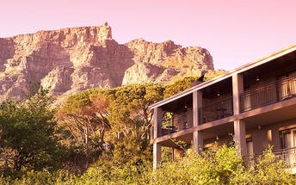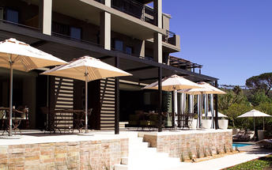

Included
Bed and Breakfast

Day 15: Travelling

Travelling

